**APU UNIVERSITY** | **LECTURER: JOSHUA SAMUEL**

**TP066168**

**INTAKE: APD1F2109CS(CYB)**

**Penang FLOOR 1**

**MODULE: CT043-3-1-IN (Degree)**

**individual assignment**

**MOHAMED KHAIRY MOHAMED ABDELRAOUF**

**INTRODUCTION TO NETWORKING**

2021

Table of Contents

RECEPTION 3

CCTV MONITORING ROOM 4

WAITING ROOM 4

CTO ROOM 5

CEO ROOM 5

EMERGENCY EXIT 6

SECURITY AND DELIVERY DEPARTMENT 6

FINANCE AND SALES DEPARTMENT 7

WORKERS’ ROOM 7

CAFETERIA 8

THEN THERE ARE THE STAIRS AND THE ELEVATORS TO THE NEXT FLOORS 9

BATHROOMS 9

ADMINISTRATIVE OFFICE 10

The Networks in the rooms 11

RECEPTION AREA 12

CCTV MONITORING ROOM 13

WAITING ROOM 14

CTO ROOM 15

CEO ROOM 16

SECURITY AND DELIVERY DEPARTMENT 17

FINANCE AND SALES DEPARTMENT 18

WORKERS’ ROOM 19

CAFETERIA 20

ADMINISTRATIVE OFFICE 21

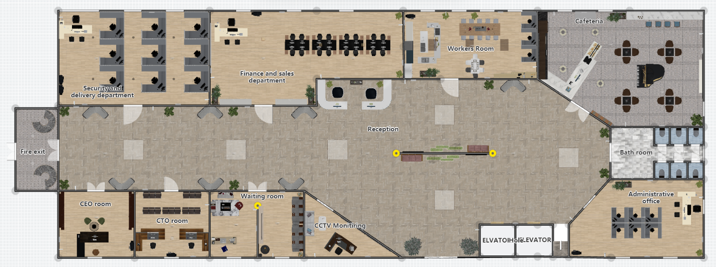

**FULL-2D FLOOR PLAN**

The **floor** consists of a large reception hall, **10 Departments**, a cafeteria, bathrooms, and an emergency exit.

|  |  |  |  |  |  |  |  |  |
| --- | --- | --- | --- | --- | --- | --- | --- | --- |
| **ROOM** | **MONITOR** | **PC** | **PRINTER** | **INTERNET**  **PHONE** | **CAM** | **IOT SMOKE**  **DETECTOR** | **AIR**  **CONDITIONER** | **ALL** |
| **RECEPTION AREA** | 2 | 2 | 1 | 1 | 9 | 4 | 5 | 24 |
| **WAITING ROOM** | 1 | 1 | 1 | 1 | 2 | 2 | 2 | 10 |
| **CEO ROOM** | 0 | 1 | 1 | 1 | 1 | 1 | 1 | 6 |
| **CTO ROOM** | 0 | 2 | 1 | 2 | 1 | 1 | 1 | 8 |
| **ADMINISTRATIVE**  **OFFICE** | 0 | 7 | 1 | 1 | 2 | 1 | 3 | 15 |
| **SECURITY AND**  **DELIVERY DEPARTMENTS** | 0 | 10 | 2 | 1 | 3 | 2 | 3 | 21 |
| **FINANCE AND**  **SALES** | 0 | 17 | 1 | 1 | 3 | 2 | 4 | 28 |
| **CCTV MONITORING**  **ROOM** | 8 | 1 | 1 | 1 | 1 | 1 | 1 | 14 |
| **CAFETERIA** | 1 | 1 | 1 | 1 | 3 | 2 | 4 | 13 |
| **WORKERS ROOM** | 1 | 3 | 1 | 1 | 2 | 1 | 3 | 12 |
| **ALL** | 13 | 45 | 11 | 11 | 27 | 17 | 27 | 151 |

**FULL-3D FLOOR PLAN**

**JUSTIFICATION OF FLOOR PLAN**

# RECEPTION

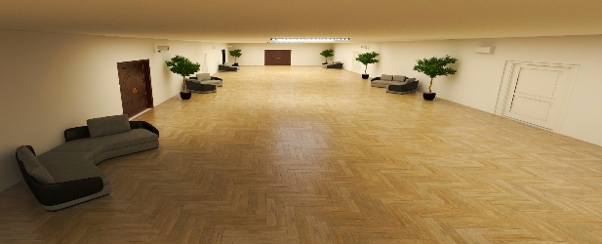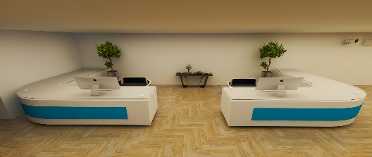When entering the first floor, there is a wall in the middle of the reception that contains a large TV and a large plant. There are two elevators to the right of the entrance and there is a staircase next to them. Each elevator can accommodate 4 people. On both sides of the entrance, there are green plants for beautification. In the front there is a large reception hall that contains two offices for reception staff, each of them has its own computer. The offices are decorated with some plants that make the employees feel psychologically comfortable while working. There are also waiting for seats next to the entrance to each room, and plants are spread in the corner of the reception hall to add an aesthetic touch. All rooms overlook the reception area.

# CCTV MONITORING ROOM

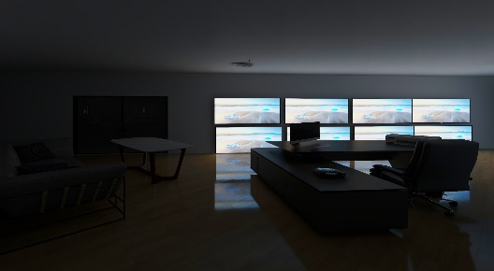To the left of the entrance there is a camera control room, and there are 8 monitoring screens and one printer. There are several advantages of CCTV monitoring room: Crime Deterrent, Peace of Mind, Evidence Collection, Dispute Settlement, Better Policy Implementation, Versatility, Helps Businesses Reduce Costs, Improves Business Reputation, and Improves Sales.

# WAITING ROOM

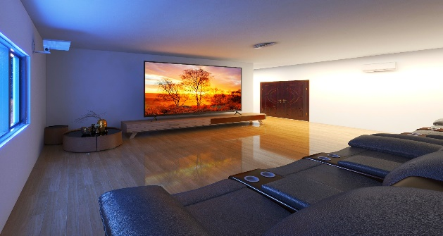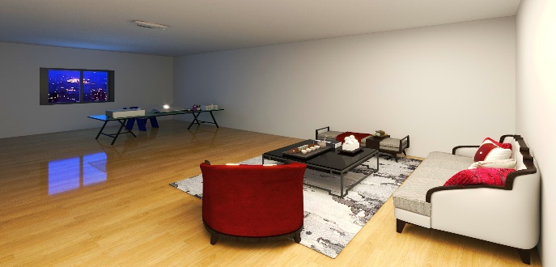Next to the CCTV room, there is a waiting room. The room is divided into two parts: The first section is the reading section, and the other section is the viewing section. Each section is provided with comfortable seats for visitors, considering the appropriate lighting for each section. There is also an air-conditioning unit and a surveillance camera. The administrative office plus the finance and sales department will be having the most visitors from non-employees, it is logical to have the waiting room located near these two offices. Although both offices have sofas, they are designed for very quick inquiries and tickets; however, for longer requests or large, time-consuming tickets, it would be better for the requester to wait in the waiting room instead.

# CTO-R-O-O-M

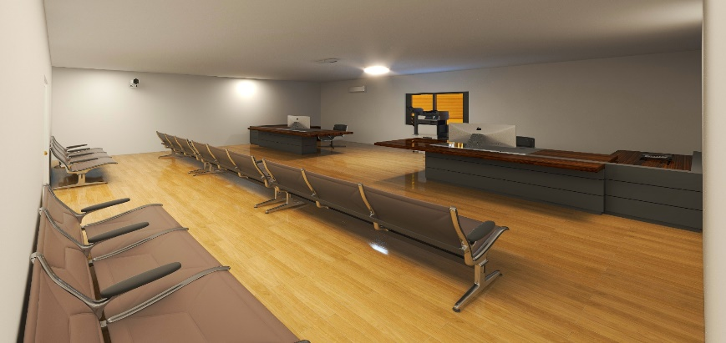To------------the--left--of--the waiting room, is the CTO room which contains two staff offices, each office has a computer and one printer. Also, there are waiting seats on both sides of the entrance to the room and in the middle. The room also has an air-conditioner to keep the place at an appropriate temperature. Technology officers play an important role in modern business. These professionals oversee the coordination of various technology-related activities as well as oversee the function and efficiency of the company's systems.

# CEO R-O-O-M

After that, there is the CEO's office, which contains a large office attached to a computer, printer, and an internet phone. In front of the office, there are two chairs with a round table for the visitors of the CEO. To the right of the entrance, there is a large library. In addition to the presence of a surveillance camera and air-conditioning. One of the most coveted titles in a company is the CEO, and this job is one of the least understood. Everyone believes that CEOs can do whatever they want, and they are all powerful and magically efficient.

# EMERGENCY EXIT

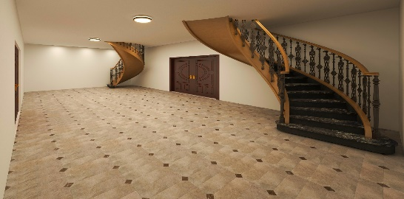 Then on the west side of the building there is an emergency exit which contains two staircases connected to the upper floor, and the emergency exit divides the reception hall into two parts to the right of the exit and to the left of it. Emergency exit routes are important because they provide a clear and safe way to evacuate the building in the event of a crisis or disaster.

# SECURITY AND DELIVERY DEPARTMENT

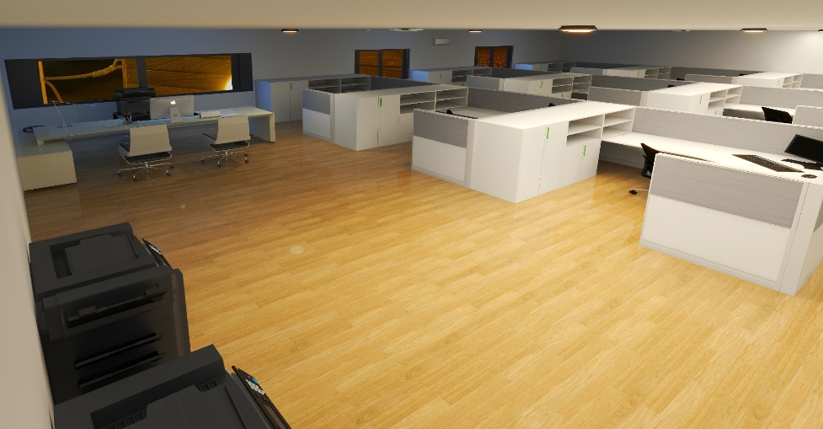In the northwest corner of the first floor, there is a security room that contains the main office for the supervisor with two seats and with his own computer and internet phone. There are also nine other offices. Each employee has his or her own office, which includes a computer, but all offices share two printers. The room is monitored by 3 CCTV cameras. The security and delivery office do not have any sofas because the security department should not have many employees who are not authorized to enter the office due to the sensitivity of the data being handled. Besides, the delivery department must deliver things, which means that it shouldn't deal with incoming requests from employees.

# FINANCE AND SALES DEPARTMENT

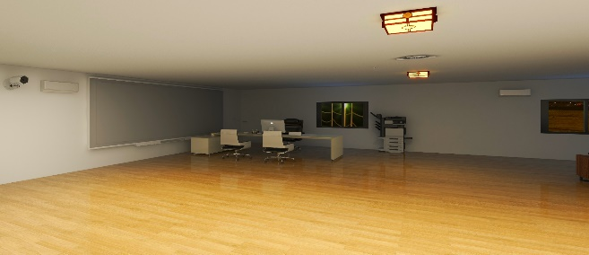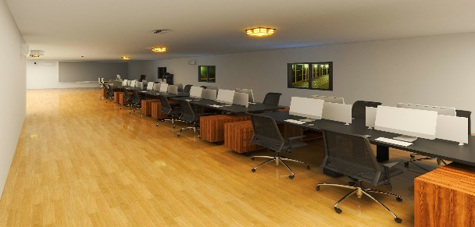 Next, we have the finance room which has a head office for the head of the department, and he has his own computer, his own internet phone, and two chairs. The room contains 16 desks in total, each desk has a computer in it for each employee. The room looks nice with some flowers in the room. There is a printer shared between all offices. The room is located near the front desk.

# WORKERS’ ROOM

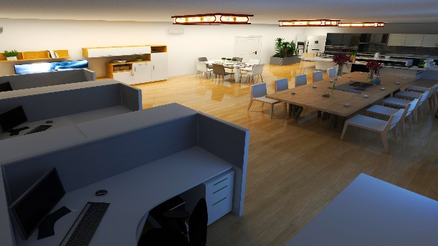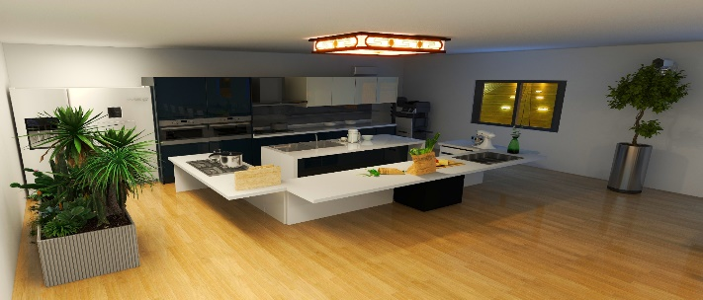 There is also a room for workers that lies between the cafeteria and the finance room, which contains a corner for meals and light drinks. There is also a kitchen dedicated to this room. and there are 3 offices, and each office is in its own block, and in front of them is an entertainment corner for entertainment.

# CAFETERIA

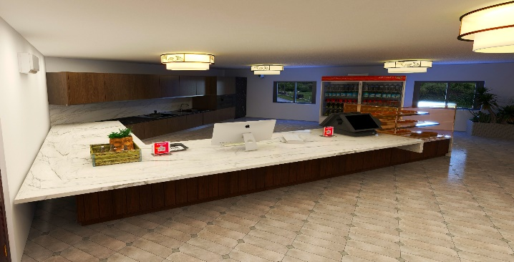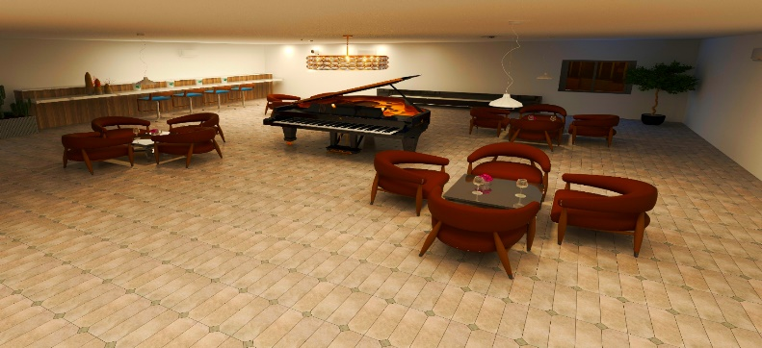 The cafeteria is one of the most important sections in the building, as it receives both employees and company visitors. Therefore, it had to be designed appropriately, so the room was adequately conditioned to keep it at the best suitable temperature and to be monitored by cameras deployed around the room. The cafeteria includes a full kitchen in addition to a refrigerator for cooling drinks. It also contains a display place for sweets such as cakes and donuts. This room contains 4 tables, each table surrounded by 4 chairs, and to entertain visitors, a piano was placed in the middle of the cafeteria. The lighting used was considered, in addition to the presence of some flowers to decorate the place.

# THEN THERE ARE THE STAIRS AND THE ELEVATORS TO THE NEXT FLOORS

# BATHR-O-O-MS

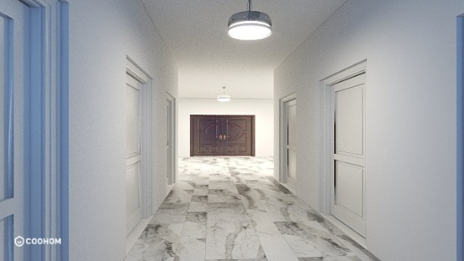 Then after the cafeteria, the men’s, and women's bathrooms each have 3 bathrooms and four sinks.

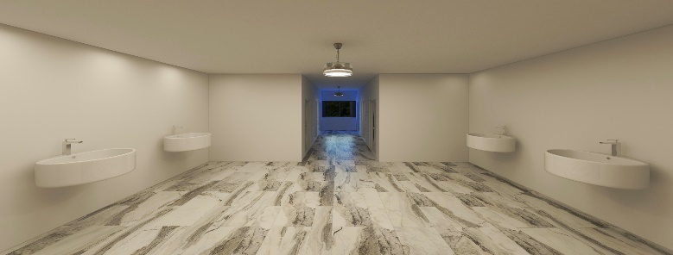

# ADMINISTRATIVE OFFICE

Finally, we have an administrative office. Administrators primarily manage servers, services, and other internal applications, so they will need computers. The main office contains a private computer, a printer, and an internet phone. There are also two seats in front of the main office. There are 6 offices, each with a computer for each employee, with some flowers for decoration and some plants in the corners of the room to add an aesthetic appearance to the room. As with the rest of the rooms, there are surveillance cameras and air-conditioning

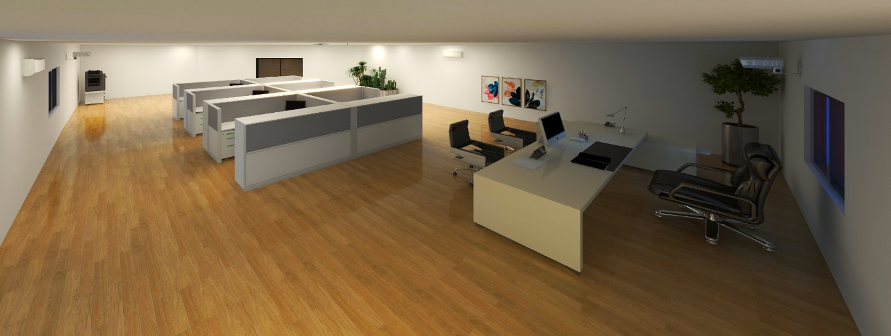

# The Networks in the rooms

**This is a physical topology of Penang Floor 1 with using Cisco Packet tracer**

# Diagram Description automatically generatedRECEPTION-AREA

|  |  |  |  |
| --- | --- | --- | --- |
| **RECEPTION AREA** | | | |
| **Name of Hosts** | **Default Gateway** | **IPV4 ADDRESS** | **SUBNETMASK** |
| **Reception-PC1** | 192.168.10.1 | 192.168.10.2 | 255.255.255.0 |
| **Reception-PC2** | 192.168.10.1 | 192.168.10.3 | 255.255.255.0 |
| **Reception CCTV-1** | 192.168.10.1 | 192.168.10.20 | 255.255.255.0 |
| **Reception CCTV-2** | 192.168.10.1 | 192.168.10.17 | 255.255.255.0 |
| **Reception CCTV-3** | 192.168.10.1 | 192.168.10.14 | 255.255.255.0 |
| **Reception CCTV-4** | 192.168.10.1 | 192.168.10.12 | 255.255.255.0 |
| **Reception CCTV-5** | 192.168.10.1 | 192.168.10.11 | 255.255.255.0 |
| **Reception CCTV-6** | 192.168.10.1 | 192.168.10.9 | 255.255.255.0 |
| **Reception CCTV-7** | 192.168.10.1 | 192.168.10.8 | 255.255.255.0 |
| **Reception CCTV-8** | 192.168.10.1 | 192.168.10.7 | 255.255.255.0 |
| **Reception CCTV-9** | 192.168.10.1 | 192.168.10.4 | 255.255.255.0 |
| **Reception IP Phone-1** | null | null | null |
| **Reception AC-1** | 192.168.10.1 | 192.168.10.18 | 255.255.255.0 |
| **Reception AC-2** | 192.168.10.1 | 192.168.10.16 | 255.255.255.0 |
| **Reception AC-3** | 192.168.10.1 | 192.168.10.13 | 255.255.255.0 |
| **Reception AC-4** | 192.168.10.1 | 192.168.10.10 | 255.255.255.0 |
| **Reception AC-5** | 192.168.10.1 | 192.168.10.8 | 255.255.255.0 |
| **Reception Printer-1** | 192.168.10.1 | 192.168.10.15 | 255.255.255.0 |
| **Reception Smoke DETECTOR-1** | 192.168.10.1 | 192.168.10.5 | 255.255.255.0 |
| **Reception Smoke DETECTOR-2** | 192.168.10.1 | 192.168.10.6 | 255.255.255.0 |
| **Reception Smoke DETECTOR-3** | 192.168.10.1 | 192.168.10.21 | 255.255.255.0 |
| **Reception Smoke DETECTOR-4** | 192.168.10.1 | 192.168.10.19 | 255.255.255.0 |

# CCTV MONITORING -ROOM

|  |  |  |  |
| --- | --- | --- | --- |
| **CCTV MONITORING ROOM** | | | |
| **Name of Hosts** | **Default Gateway** | **IPV4 ADDRESS** | **SUBNETMASK** |
| **CCTVMR PC-1** | 192.168.10.1 | 192.168.10.77 | 255.255.255.0 |
| **CCTVMR Printer-1** | 192.168.10.1 | 192.168.10.78 | 255.255.255.0 |
| **CCTVMR CCTV** | 192.168.10.1 | 192.168.10.126 | 255.255.255.0 |
| **CCTVMR AC-1** | 192.168.10.1 | 192.168.10.76 | 255.255.255.0 |
| **CCTVMR IP Phone** | null | null | null |
| **CCTVMR SMOKE DETECTOR** | 192.168.10.1 | 192.168.10.79 | 255.255.255.0 |

# A picture containing diagram Description automatically generatedWAITING -ROOM

|  |  |  |  |
| --- | --- | --- | --- |
| **WATING ROOM** | | | |
| **Name of Hosts** | Default Gateway | IPV4 ADDRESS | SUBNETMASK |
| **WATING ROOM PC-1** | 192.168.10.1 | 192.168.10.29 | 255.255.255.0 |
| **WATING ROOM CCTV-1** | 192.168.10.1 | 192.168.10.23 | 255.255.255.0 |
| **WATING ROOM CCTV-2** | 192.168.10.1 | 192.168.10.26 | 255.255.255.0 |
| **WATING ROOM AC-1** | 192.168.10.1 | 192.168.10.27 | 255.255.255.0 |
| **WATING ROOM AC-2** | 192.168.10.1 | 192.168.10.30 | 255.255.255.0 |
| **WATING ROOM IP Phone-1** | null | null | null |
| **WATING ROOM Printer-1** | 192.168.10.1 | 192.168.10.28 | 255.255.255.0 |
| **WATING ROOM SMOKE DETECTOR-1** | 192.168.10.1 | 192.168.10.22 | 255.255.255.0 |
| **WATING ROOM SMOKE DETECTOR-2** | 192.168.10.1 | 192.168.10.25 | 255.255.255.0 |

# CTO -ROOM

|  |  |  |  |
| --- | --- | --- | --- |
| **CTO ROOM** | | | |
| **Name of Hosts** | **Default Gateway** | **IPV4 ADDRESS** | **SUBNETMASK** |
| **CTO ROOM CCTV-1** | 192.168.10.1 | 192.168.10.36 | 255.255.255.0 |
| **CTO ROOM AC-1** | 192.168.10.1 | 192.168.10.34 | 255.255.255.0 |
| **CTO ROOM PC-1** | 192.168.10.1 | 192.168.10.32 | 255.255.255.0 |
| **CTO ROOM PC-2** | 192.168.10.1 | 192.168.10.33 | 255.255.255.0 |
| **CTO ROOM Printer-1** | 192.168.10.1 | 192.168.10.31 | 255.255.255.0 |
| **CTO ROOM IP Phone-1** | null | null | null |
| **CTO ROOM IP Phone-2** | null | null | null |
| **CTO ROOM SMOKE DETECTOR-1** | 192.168.10.1 | 192.168.10.35 | 255.255.255.0 |

# CEO -ROOM

|  |  |  |  |
| --- | --- | --- | --- |
| **CEO ROOM** | | | |
| **Name of Hosts** | **Default Gateway** | **IPV4 ADDRESS** | **SUBNETMASK** |
| **CEO PC-1** | 192.168.10.1 | 192.168.10.122 | 255.255.255.0 |
| **CEO CCTV-1** | 192.168.10.1 | 192.168.10.123 | 255.255.255.0 |
| **CEO IP Phone-2** | null | null | null |
| **CEO Printer** | 192.168.10.1 | 192.168.10.124 | 255.255.255.0 |
| **CEO AC-1** | 192.168.10.1 | 192.168.10.121 | 255.255.255.0 |
| **CEO SMOKE DETECTOR-1** | 192.168.10.1 | 192.168.10.125 | 255.255.255.0 |

# SECURITY AND DELIVERY DEPARTMENT

|  |  |  |  |
| --- | --- | --- | --- |
| **SECURITY AND DELIVERY DEPARTMENT** | | | |
| **Name of Hosts** | **Default Gateway** | **IPV4 ADDRESS** | **SUBNETMASK** |
| **SADD CCTV-1** | 192.168.10.1 | 192.168.10.37 | 255.255.255.0 |
| **SADD CCTV-2** | 192.168.10.1 | 192.168.10.38 | 255.255.255.0 |
| **SADD CCTV-3** | 192.168.10.1 | 192.168.10.56 | 255.255.255.0 |
| **SADD PC-1** | 192.168.10.1 | 192.168.10.39 | 255.255.255.0 |
| **SADD PC-2** | 192.168.10.1 | 192.168.10.40 | 255.255.255.0 |
| **SADD PC-3** | 192.168.10.1 | 192.168.10.41 | 255.255.255.0 |
| **SADD PC-4** | 192.168.10.1 | 192.168.10.42 | 255.255.255.0 |
| **SADD PC-5** | 192.168.10.1 | 192.168.10.43 | 255.255.255.0 |
| **SADD PC-6** | 192.168.10.1 | 192.168.10.44 | 255.255.255.0 |
| **SADD PC-7** | 192.168.10.1 | 192.168.10.45 | 255.255.255.0 |
| **SADD PC-8** | 192.168.10.1 | 192.168.10.47 | 255.255.255.0 |
| **SADD PC-9** | 192.168.10.1 | 192.168.10.48 | 255.255.255.0 |
| **SADD PC-10** | 192.168.10.1 | 192.168.10.50 | 255.255.255.0 |
| **SADD Printer-1** | 192.168.10.1 | 192.168.10.46 | 255.255.255.0 |
| **SADD Printer-2** | 192.168.10.1 | 192.168.10.49 | 255.255.255.0 |
| **SADD AC-1** | 192.168.10.1 | 192.168.10.55 | 255.255.255.0 |
| **SADD AC-2** | 192.168.10.1 | 192.168.10.53 | 255.255.255.0 |
| **SADD AC-3** | 192.168.10.1 | 192.168.10.51 | 255.255.255.0 |
| **SADD SMOKE DETECTOR-1** | 192.168.10.1 | 192.168.10.54 | 255.255.255.0 |
| **SADD SMOKE DETECTOR-2** | 192.168.10.1 | 192.168.10.52 | 255.255.255.0 |
| **SADD IP Phone** | null | null | null |

# FINANCE AND SALES DEPARTMENT

|  |  |  |  |
| --- | --- | --- | --- |
| **FINANCE AND SALES DEPARTMENT** | | | |
| **Name of Hosts** | **Default Gateway** | **IPV4 ADDRESS** | **SUBNETMASK** |
| **FACD CCTV-1** | 192.168.10.1 | 192.168.10.93 | 255.255.255.0 |
| **FACD CCTV-2** | 192.168.10.1 | 192.168.10.101 | 255.255.255.0 |
| **FACD C**--**CTV-3** | 192.168.10.1 | 192.168.10.95 | 255.255.255.0 |
| **FACD AC-1** | 192.168.10.1 | 192.168.10.91 | 255.255.255.0 |
| **FACD AC-2** | 192.168.10.1 | 192.168.10.88 | 255.255.255.0 |
| **FACD AC-3** | 192.168.10.1 | 192.168.10.86 | 255.255.255.0 |
| **FACD AC-4** | 192.168.10.1 | 192.168.10.84 | 255.255.255.0 |
| **FACD Printer** | 192.168.10.1 | 192.168.10.96 | 255.255.255.0 |
| **FACD IP Phone** | null | null | null |
| **FACD PC-**------**1** | 192.168.10.1 | 192.168.10.90 | 255.255.255.0 |
| **FACD PC-**------**2** | 192.168.10.1 | 192.168.10.89 | 255.255.255.0 |
| **FACD PC-**------**3** | 192.168.10.1 | 192.168.10.87 | 255.255.255.0 |
| **FACD PC-**------**4** | 192.168.10.1 | 192.168.10.85 | 255.255.255.0 |
| **FACD PC-**------**5** | 192.168.10.1 | 192.168.10.83 | 255.255.255.0 |
| **FACD PC-**------**6** | 192.168.10.1 | 192.168.10.82 | 255.255.255.0 |
| **FACD PC-**------**7** | 192.168.10.1 | 192.168.10.81 | 255.255.255.0 |
| **FACD PC-**----**8** | 192.168.10.1 | 192.168.10.80 | 255.255.255.0 |
| **FACD PC-**----**9** | 192.168.10.1 | 192.168.10.106 | 255.255.255.0 |
| **FACD PC-**------**10** | 192.168.10.1 | 192.168.10.105 | 255.255.255.0 |
| **FACD PC-**----**11** | 192.168.10.1 | 192.168.10.104 | 255.255.255.0 |
| **FACD PC-**----**12** | 192.168.10.1 | 192.168.10.103 | 255.255.255.0 |
| **FACD PC-**----**13** | 192.168.10.1 | 192.168.10.102 | 255.255.255.0 |
| **FACD PC**----**-14** | 192.168.10.1 | 192.168.10.100 | 255.255.255.0 |
| **FACD PC**------**-15** | 192.168.10.1 | 192.168.10.98 | 255.255.255.0 |
| **FACD PC-16** | 192.168.10.1 | 192.168.10.97 | 255.255.255.0 |
| **FACD PC-17** | 192.168.10.1 | 192.168.10.99 | 255.255.255.0 |
| **FACD SMOKE D**-**ETECTOR -1** | 192.168.10.1 | 192.168.10.94 | 255.255.255.0 |
| **FACD SMOKE DETECTOR -2** | 192.168.10.1 | 192.168.10.92 | 255.255.255.0 |

# WORKERS’-ROOM

|  |  |  |  |
| --- | --- | --- | --- |
| **WORKERS’ ROOM** | | | |
| **Name of Hosts** | **Default Gateway** | **IPV4 ADDRESS** | **SUBNETMASK** |
| **WORKERS’ ROOM PC-1** | 192.168.10.1 | 192.168.10.75 | 255.255.255.0 |
| **WORKERS’ ROOM PC-2** | 192.168.10.1 | 192.168.10.73 | 255.255.255.0 |
| **WORKERS’ ROOM PC-3** | 192.168.10.1 | 192.168.10.66 | 255.255.255.0 |
| **WORKERS’ ROOM PRINTER** | 192.168.10.1 | 192.168.10.74 | 255.255.255.0 |
| **WORKERS’ ROOM IP Phone** | null | null | null |
| **WORKERS’ ROOM AC-1** | 192.168.10.1 | 192.168.10.71 | 255.255.255.0 |
| **WORKERS’ ROOM AC-2** | 192.168.10.1 | 192.168.10.130 | 255.255.255.0 |
| **WORKERS’ ROOM AC-3** | 192.168.10.1 | 192.168.10.68 | 255.255.255.0 |
| **WORKERS’ ROOM CCTV-1** | 192.168.10.1 | 192.168.10.72 | 255.255.255.0 |
| **WORKERS’ ROOM CCTV-2** | 192.168.10.1 | 192.168.10.70 | 255.255.255.0 |
| **WORKERS’ ROOM CCTV-3** | 192.168.10.1 | 192.168.10.69 | 255.255.255.0 |
| **WORKERS’ ROOM SMOKE DETECTOR-1** | 192.168.10.1 | 192.168.10.67 | 255.255.255.0 |

# CAFETERIA

|  |  |  |  |
| --- | --- | --- | --- |
| **CAFETERIA** | | | |
| **Name of Hosts** | **Default Gateway** | **IPV4 ADDRESS** | **SUBNETMASK** |
| **CAFETERIA CCTV-1** | 192.168.10.1 | 192.168.10.58 | 255.255.255.0 |
| **CAFETERIA CCTV-2** | 192.168.10.1 | 192.168.10.59 | 255.255.255.0 |
| **CAFETERIA CCTV-3** | 192.168.10.1 | 192.168.10.60 | 255.255.255.0 |
| **CAFETERIA Printer-1** | 192.168.10.1 | 192.168.10.61 | 255.255.255.0 |
| **CAFETERIA PC-1** | 192.168.10.1 | 192.168.10.62 | 255.255.255.0 |
| **CAFETERIA AC-1** | 192.168.10.1 | 192.168.10.65 | 255.255.255.0 |
| **CAFETERIA AC-2** | 192.168.10.1 | 192.168.10.63 | 255.255.255.0 |
| **CAFETERIA SMOKE DETECTOR-1** | 192.168.10.1 | 192.168.10.57 | 255.255.255.0 |
| **CAFETERIA SMOKE DETECTOR-2** | 192.168.10.1 | 192.168.10.64 | 255.255.255.0 |
| **CAFETERIA IP Phone-1** | null | null | null |

# ADMINISTRATIVE OFFICE

|  |  |  |  |
| --- | --- | --- | --- |
| **ADMINISTRATIVE OFFICE** | | | |
| **Name of Hosts** | **Default Gateway** | **IPV4 ADDRESS** | **SUBNETMASK** |
| **ADMIN PC-1** | 192.168.10.1 | 192.168.10.118 | 255.255.255.0 |
| **ADMIN PC-2** | 192.168.10.1 | 192.168.10.108 | 255.255.255.0 |
| **ADMIN PC-3** | 192.168.10.1 | 192.168.10.109 | 255.255.255.0 |
| **ADMIN PC-4** | 192.168.10.1 | 192.168.10.110 | 255.255.255.0 |
| **ADMIN PC-5** | 192.168.10.1 | 192.168.10.111 | 255.255.255.0 |
| **ADMIN PC-6** | 192.168.10.1 | 192.168.10.112 | 255.255.255.0 |
| **ADMIN PC-7** | 192.168.10.1 | 192.168.10.113 | 255.255.255.0 |
| **ADMIN AC-1** | 192.168.10.1 | 192.168.10.115 | 255.255.255.0 |
| **ADMIN AC-2** | 192.168.10.1 | 192.168.10.117 | 255.255.255.0 |
| **ADMIN AC-3** | 192.168.10.1 | 192.168.10.107 | 255.255.255.0 |
| **ADMIN PRINTER** | 192.168.10.1 | 192.168.10.119 | 255.255.255.0 |
| **ADMIN CCTV-1** | 192.168.10.1 | 192.168.10.116 | 255.255.255.0 |
| **ADMIN CCTV-2** | 192.168.10.1 | 192.168.10.120 | 255.255.255.0 |
| **ADMIN SMOKE DETECTOR -1** | 192.168.10.1 | 192.168.10.114 | 255.255.255.0 |
| **ADMIN IP Phone** | null | null | null |

|  |  |  |  |  |  |  |  |  |
| --- | --- | --- | --- | --- | --- | --- | --- | --- |
| **PENANG FLOOR 1** |  |  |  |  |  |  |  |  |
| **AREA** | **NUMBER OF HOST USED** | **unused hosts** | **Total hosts** | **NETWORD ID** | **DEFAULT GATEWAY** | **SUBNET MASK** | **VALID RANGE OF HOST IP ADDRESS** | **BROADCAST IP** |
| Reception area | 24 | 103 | 254 | 192.168.10.0/24 | 192.168.10.1 | 255.255.255.0 | 192.168.10.1 - 192.168.10.24 | 255.255.255.255 |
| waiting room | 10 | 192.168.10.0/24 | 192.168.10.1 | 255.255.255.0 | 192.168.10.29 - 192.168.10.30 | 255.255.255.255 |
| CEO room | 6 | 192.168.10.0/24 | 192.168.10.1 | 255.255.255.0 | 192.168.10.122 - 192.168.10.125 | 255.255.255.255 |
| CTO room | 8 | 192.168.10.0/24 | 192.168.10.1 | 255.255.255.0 | 192.168.10.31 - 192.168.10.36 | 255.255.255.255 |
| Administrative office | 15 | 192.168.10.0/24 | 192.168.10.1 | 255.255.255.0 | 192.168.10.108 - 192.168.10.120 | 255.255.255.255 |
| Security and Delivery departments | 21 | 192.168.10.0/24 | 192.168.10.1 | 255.255.255.0 | 192.168.10.80 - 192.168.10.106 | 255.255.255.255 |
| Finance and Sales | 28 | 192.168.10.0/24 | 192.168.10.1 | 255.255.255.0 | 192.168.10.80 - 192.168.10.101 | 255.255.255.255 |
| CCTV MONITORING ROOM | 14 | 192.168.10.0/24 | 192.168.10.1 | 255.255.255.0 | 192.168.10.77 - 192.168.10.79 | 255.255.255.255 |
| Cafeteria | 13 | 192.168.10.0/24 | 192.168.10.1 | 255.255.255.0 | 192.168.10.58 - 192.168.10.65 | 255.255.255.255 |
| Workers room | 12 | 192.168.10.0/24 | 192.168.10.1 | 255.255.255.0 | 192.168.10.66 - 192.168.10.74 | 255.255.255.255 |
| TOTAL HOSTS | 151 |  |  |  |  |  |  |  |

On the primary floor of Penang Working, there are ten switches that associates with end gadgets. The switches are utilizing 2960 switches of Cisco Parcel Tracer and utilizing copper get over link interfaces all switches. Ten of the switches address to various region in this floor. There are 151 hosts remember utilized host and saved host for this floor.

Thus, the IP address with prefix/24 is utilized. The justification behind utilizing this IP address is on the grounds that it can give 254 hosts utilized. As per the IP tending to table over, the Network ID that utilizing in this floor is {19--2.168.10.0/24} with a subnet veil of{255--.255--.255--.0} and the **d**efault Gateway is {1--92.168.1--0.1}

As indicated by Graph over, each host in this floor has been given an exceptional IP address so we can keep away from IP struggle. Other than that, subnet cover and default door likewise be give--n to each host in this floor.

Each switch in this floor is completely arranged. Every one of the switches have been given a hostname and a secret word, which just know by administrator. This is the screen capture of each switch in the floor.

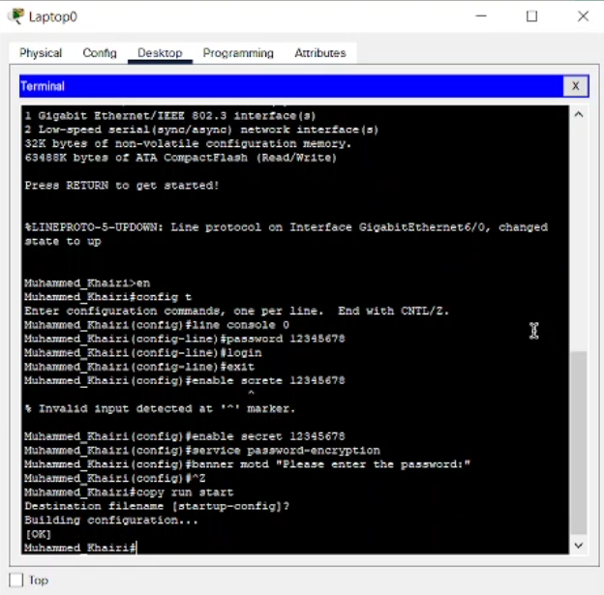 The switch in this floor is completely designed and has given Ip address 192.168.10.1 and subnet veil 255.255.255.0 and have been given a host name and a secret key, this is the screen shot.

# References

1. Samuel, J. [IN]. (2021, October 21). *how router configuration works* [Video]. Teams.

<https://cloudmails.sharepoint.com/sites/IN-2109-LAB-19/Shared%20Documents/General/Recordings/Meeting%20in%20_General_-20211021_140027-Meeting%20Recording.mp4>

1. Coohom. (n.d.). *Design*. Retrieved December 1, 2021, from

<https://www.coohom.com/>

1. *Cisco Packet Tracer*. (n.d.). Cisco. Retrieved November 1, 2021, from

<https://www.netacad.com/courses/packet-tracer>

1. *Basic Router Configuration*. (2017, November 6). Cisco. Retrieved December 3, 2021, from:

<https://www.cisco.com/c/en/us/td/docs/routers/access/800M/software/800MSCG/routconf.html>

1. Electrical & Computer Engineering Project. (2019, July 18). *Cisco Packet Tracer Tutorial -Part 01 | Switch & end device connection* [Video]. YouTube.

<https://www.youtube.com/watch?v=YZRQpZPp4E4>

1. Cisco. (2021, May 21). IP Addressing and Subnetting for New Users. Retrieved from Cisco:

<https://www.cisco.com/c/en/us/support/docs/ip/routing-information-protocol-rip/13788-3.html>

**IMPORTANT NOTE:**

**IT IS VERY HELPFUL TO WATCH THE RECORDING MORE THAN ONCE CAUSE ITS WAY BETTER THAN WATCHING YOUTUBE VIDEOS SPECIFCALLY WHEN WE HAVE A GREAT LECTURER**

* **How TO DEAL WITH PACKT TRACER**
* **HOW TO DESIGN IN 3D AND 2D**
* **THE DIFFRENCE BETWEEN WIRES IN THE NETWORKS**
* **HOW TO CONFIGURE A ROUTER AND A PASSWORD WITH TERMNAL**
* **HOW TO CONFIGURE A SWITCH AND A PASSWORD WITH TERMNAL**
* **WHAT IS MEANT BY IP AND SUBNETMASK**
* **THE PORTS OF THE DEVICES LIKE ETHERNET ETC**
* **WHAT IS MEANT BY DEFAULT GATE WAY**
* **WHAT IS MEANT BY HOST AND CLINT?**
* **THE IOT DEVICES**
* **IP ADDRESING**
* **IP ROUTING**

***WHAT I HAVE LEARND WITH THIS ASIGHMENT***

***THE PROGRAM USED IN DESIGNING IS COOHOM***

***THE PROGRAM USED IN NETWORKS IS PACKT TRACER***

***MORE REFERENCE***